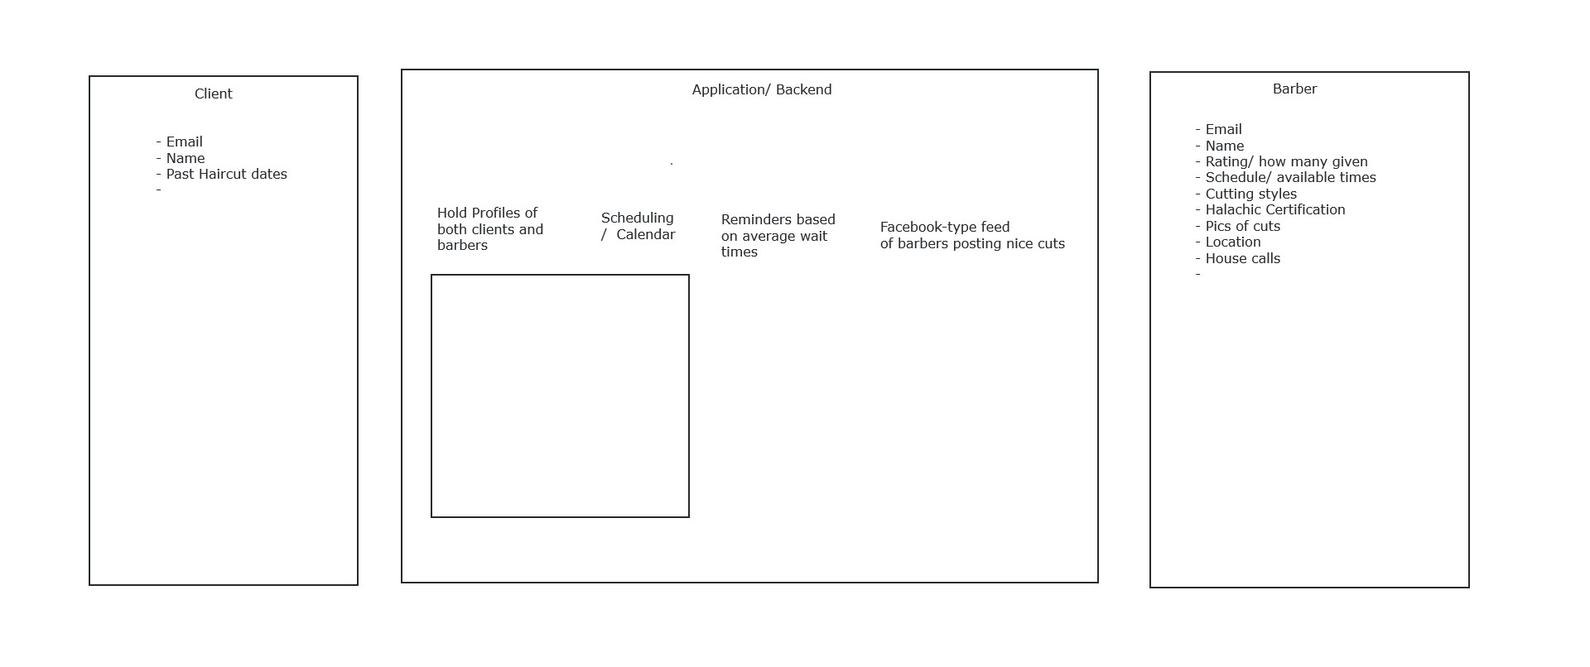

A Barber finding and scheduling application

Sync-ed CRUD Operator

Listener

Data Store

H3